Employee Feedback Continuum

Think of everyone on your team and place each of their names/initials on the model below:

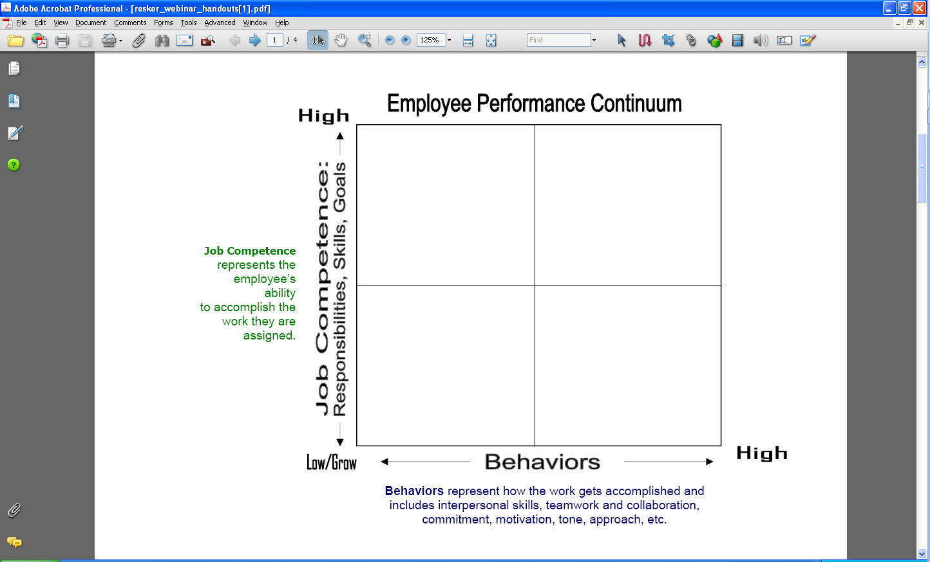

For more information on our leadership & management courses and certificate programs,

please contact the Corporate Education Group at 1.800.288.7246. Also, check us out on the

web at **www.corpedgroup.com.**