**Johari Window Employee Performance Model**

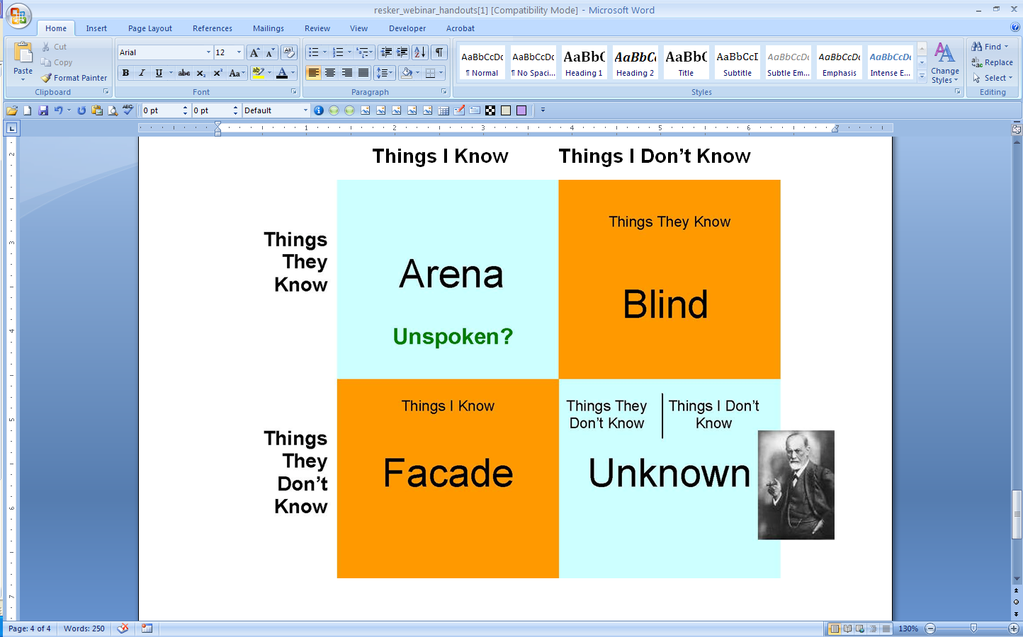

*\*Source: The Johari window, represents a graphic model for mapping interpersonal awareness" and was created by Joseph Luft and Harry Ingham in 1955.*

For more information on our leadership & management courses and certificate programs, please contact the Corporate Education Group at 1.800.288.7246. Also, check us out on the web at **www.corpedgroup.com.**