**Stages of Intervention Model**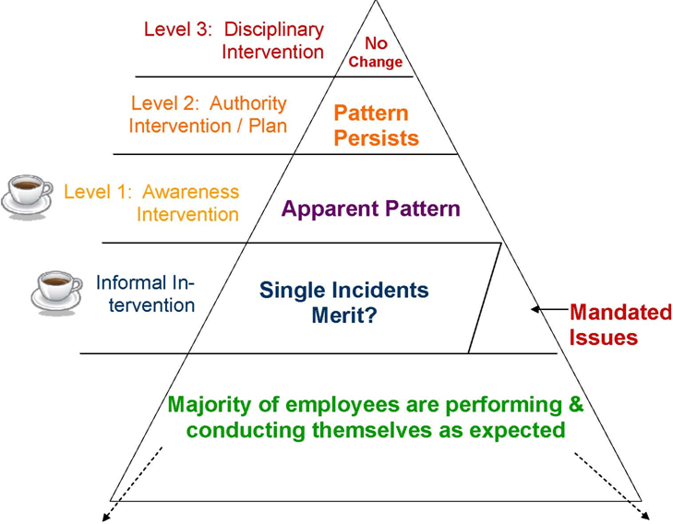  
  
*\*Source: Model Modified from the Vanderbilt University Medical Center*

For more information on our leadership & management courses and certificate programs, please contact the Corporate Education Group at 1.800.288.7246. Also, check us out on the web at **www.corpedgroup.com.**