Cause and Effect Diagram Template 1

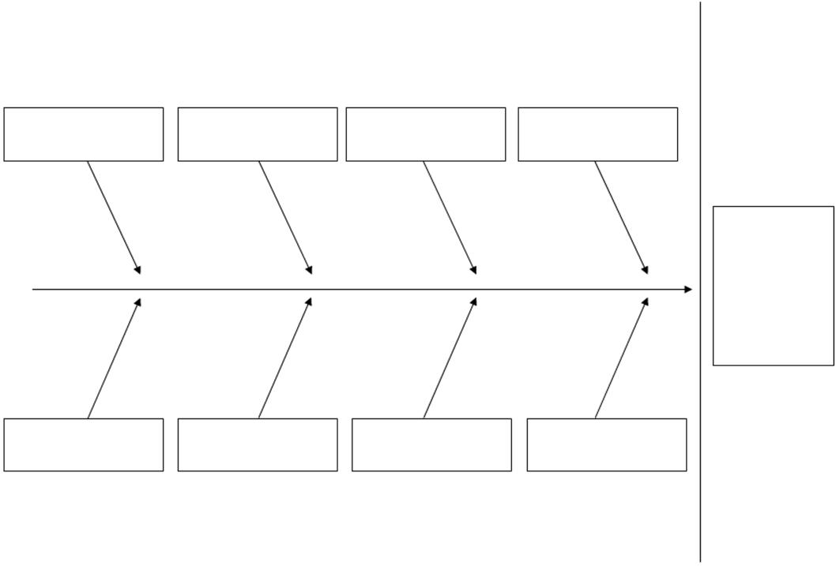*Extracted from MDP273a: Project Risk Management*