WBS Graphical Template

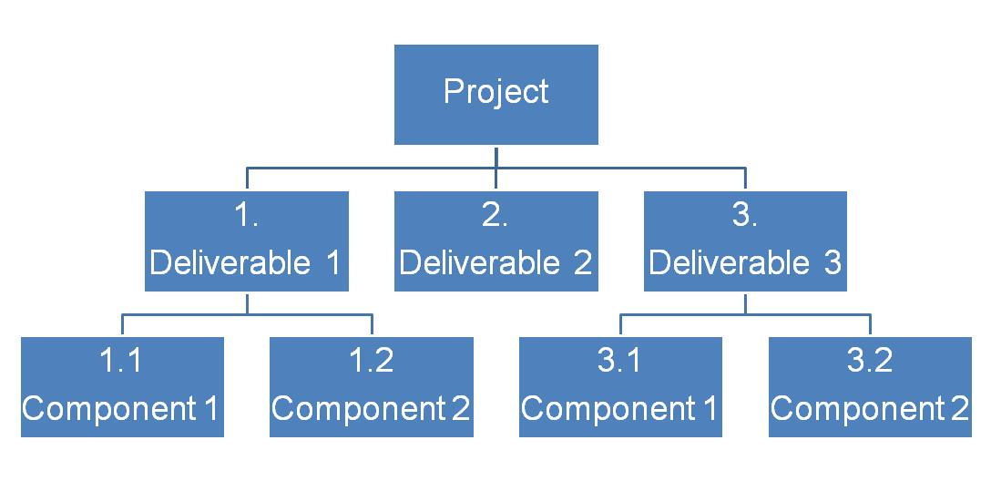*Extracted from MDP189a: Project Scope Management*